Project Planning Phase
Project Planning Template (Product Backlog, Sprint Planning, Stories, Story points)

Date | 16 January 2026
Team ID | SWTID-2026-7310
Project Name | Auto Ticket Classification using Flow Designer
Maximum Marks | 5 Marks

Product Backlog, Sprint Schedule, and Estimation (4 Marks)
Use the below template to create product backlog and sprint schedule
Sprint | Functional Requirement (Epic) | User Story Number | User Story / Task | Story Points | Priority | Team Members
Sprint-1 | Environment Setup | USN-1 | As an administrator, I create a new update set 'Project Update Set' (In progress, Global) and make it current. | 1 | High | Mohan Kumar S
Sprint-1 | Data Model | USN-2 | As an administrator, I create the custom table Incident WorkFlow with auto-number (INC prefix). | 2 | High | Muhammed Ibrahim A
Sprint-1 | Data Model | USN-3 | As an administrator, I create the fields Number, Caller, Category, Subcategory, Short Description, Description, State, Assigned Group, Assigned To. | 3 | High | Ponakilan J
Sprint-1 | Data Model | USN-4 | As an administrator, I add choice lists to Category, Subcategory and State. | 2 | High | Pradeep B
Sprint-1 | Data Model | USN-5 | As an administrator, I make Subcategory dependent on Category so options change by category. | 3 | High | Ragulprathap R
Sprint-2 | Flow Automation | USN-6 | As an administrator, I create the flow 'Auto Classify School IT Tickets' with trigger Record Created and condition Category is empty. | 2 | High | Mohan Kumar S
Sprint-2 | Flow Automation | USN-7 | As a caller, my Wi-Fi / network ticket is classified as Network > Wi-Fi. | 2 | High | Muhammed Ibrahim A
Sprint-2 | Flow Automation | USN-8 | As a caller, my projector ticket is classified as Hardware > Projector. | 1 | High | Ponakilan J
Sprint-2 | Flow Automation | USN-9 | As a caller, my password ticket is classified as Access > Forgot Password. | 1 | Medium | Pradeep B
Sprint-2 | Flow Automation | USN-10 | As a caller, my slow computer ticket is classified as Performance > Slow Computer. | 1 | Medium | Ragulprathap R
Sprint-2 | Email Notification | USN-11 | As a caller, I receive a confirmation email (Send Email action to Caller > Email) after my ticket is classified. | 3 | High | Mohan Kumar S
Sprint-2 | Flow Automation | USN-12 | As an administrator, I activate the flow. | 2 | High | Muhammed Ibrahim A
Sprint-3 | Testing & Validation | USN-13 | As a tester, I run Test Scenario 1 (Wi-Fi/Network ticket) and verify Category and Subcategory. | 2 | High | Ponakilan J
Sprint-3 | Testing & Validation | USN-14 | As a tester, I run Test Scenario 2 (projector ticket) and verify the result. | 2 | High | Pradeep B
Sprint-3 | Testing & Validation | USN-15 | As a tester, I check the email in System Logs > Emails and preview it. | 2 | High | Ragulprathap R
Sprint-3 | Testing & Validation | USN-16 | As an administrator, I validate data (mandatory fields, unique auto-number, references) and security access. | 3 | Medium | Mohan Kumar S
Sprint-3 | Deployment | USN-17 | As an administrator, I set the update set to Complete and export it as XML. | 2 | High | Muhammed Ibrahim A
Sprint-3 | Documentation | USN-18 | As a team, we complete the project documentation and final report. | 1 | Medium | Whole team

Project Tracker, Velocity & Burndown Chart: (4 Marks)
Sprint | Total Story Points | Duration | Sprint Start Date | Sprint End Date (Planned) | Story Points Completed (as on Planned End Date) | Sprint Release Date (Actual)
Sprint-1 | 11 | 6 Days | 19 Jan 2026 | 24 Jan 2026 | 11 | 24 Jan 2026
Sprint-2 | 12 | 6 Days | 26 Jan 2026 | 31 Jan 2026 | 12 | 31 Jan 2026
Sprint-3 | 12 | 6 Days | 02 Feb 2026 | 07 Feb 2026 | 12 | 07 Feb 2026

Velocity:
Sprint duration = 6 days. Total story points = 11 + 12 + 12 = 35 across 3 sprints.
Team velocity = total story points completed / number of sprints = 35 / 3 = 11.67, i.e. about 12 story points per sprint.
Average velocity per day (AV) = velocity / sprint duration = 11.67 / 6 = about 1.94 story points per day.

Burndown Chart:
A burn down chart is a graphical representation of work left to do versus time. It is often used in agile software development methodologies such as Scrum. However, burn down charts can be applied to any project containing measurable progress over time.
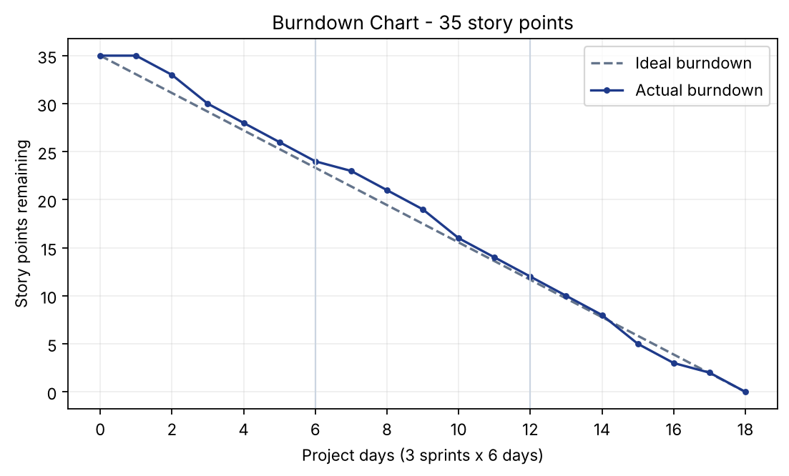
https://www.visual-paradigm.com/scrum/scrum-burndown-chart/
https://www.atlassian.com/agile/tutorials/burndown-charts

Reference:
https://www.atlassian.com/agile/project-management
https://www.atlassian.com/agile/tutorials/how-to-do-scrum-with-jira-software
https://www.atlassian.com/agile/tutorials/epics
https://www.atlassian.com/agile/tutorials/sprints
https://www.atlassian.com/agile/project-management/estimation
https://www.atlassian.com/agile/tutorials/burndown-charts

